**Step1** : **Create a new Static Web App :**

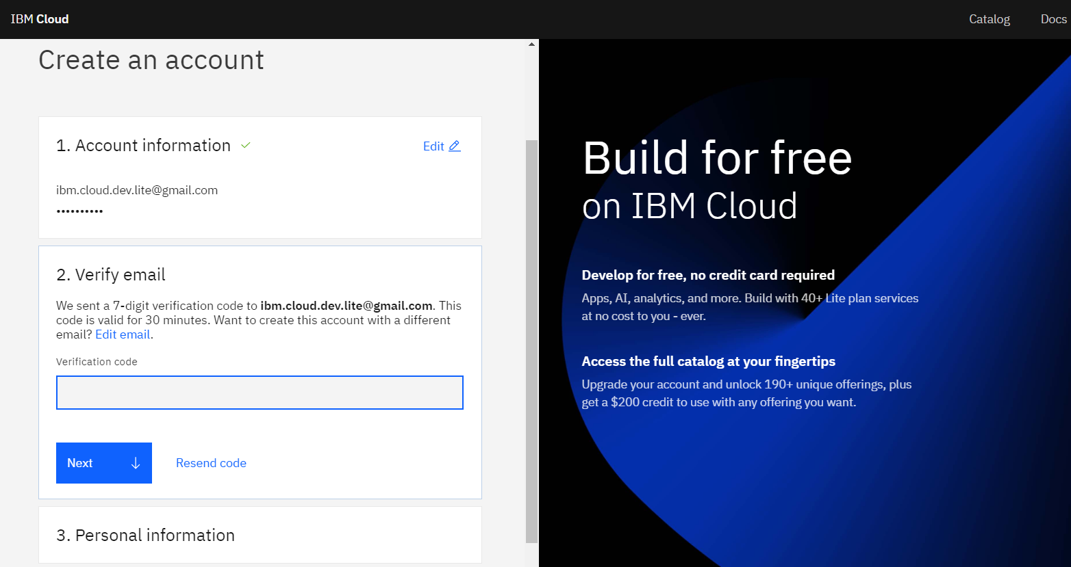

**Step 2: Create a New Repository:**

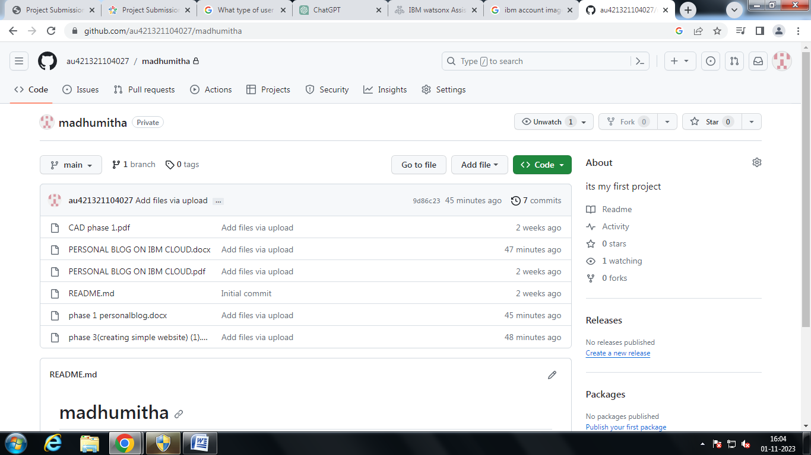

**Step 3: using template create a HTML website :**

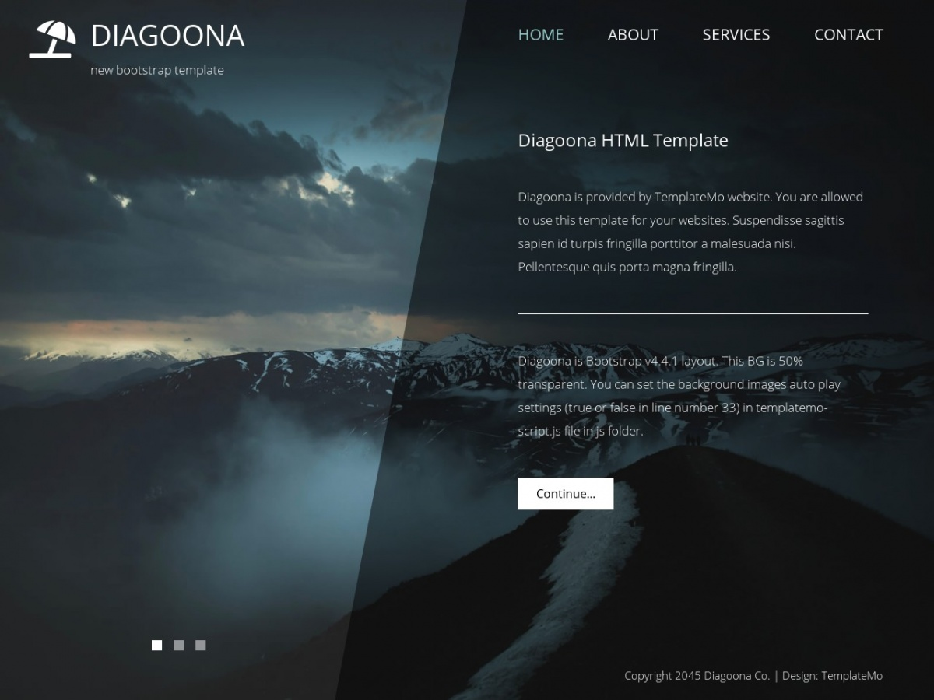

**Step 4: Azure Portal:**

**Log in to the Azure Portal (**[**https://portal.azure.com**](https://portal.azure.com)**).**

1. Go to https://www.azure.com and click the green “Start free” button. ...
2. Next, click another “Start free” button. ...
3. If you already have an account with Microsoft, for example, Microsoft 365, you'll be prompted to log in. ..
4. When you log in, some of your details may already be there.

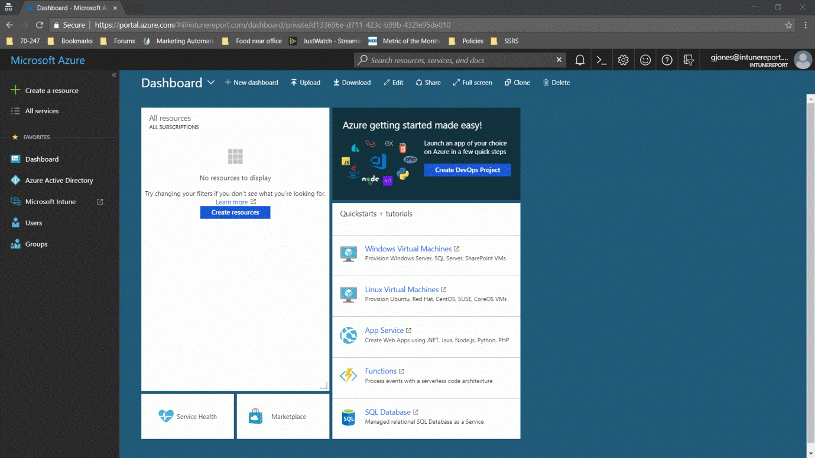

**Step 5:** **Create a New Static Web App:**

* **Sign in to the Azure portal.**
* **Select Resource groups.**
* **Select Create.**

